* Install XMAPP
  + https://www.apachefriends.org/index.html
  + Install for your PC
  + Turn on Apache and MySQL
  + Click on Admin for MySQL, it will open PHPmyadmin webpage.
    - Here you will create and host your database.
    - You can write SQL or just use the options available without writing SQL
  + 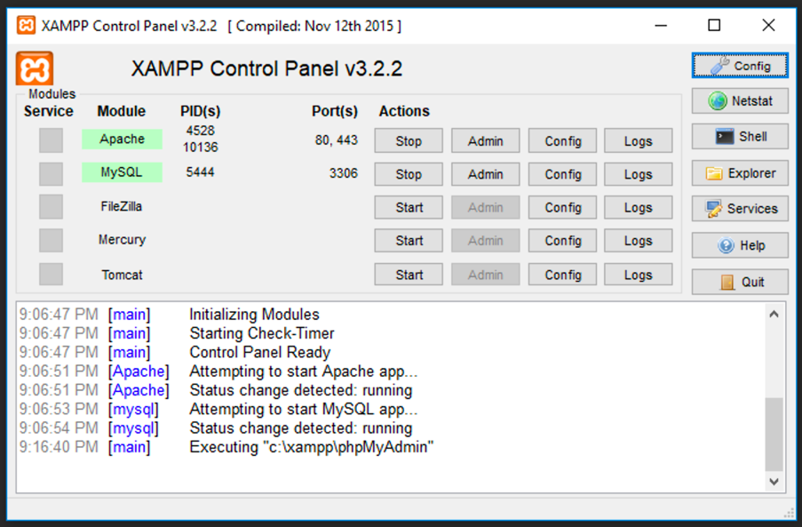
  + Click on SQL tab on PhpMyadmin page
  + Here you will write all the SQL script to create database and add tables.
    - For now, Please copy the text from JewelryDB.sql and paste it here
    - Click go. It will create the database and user table
  + 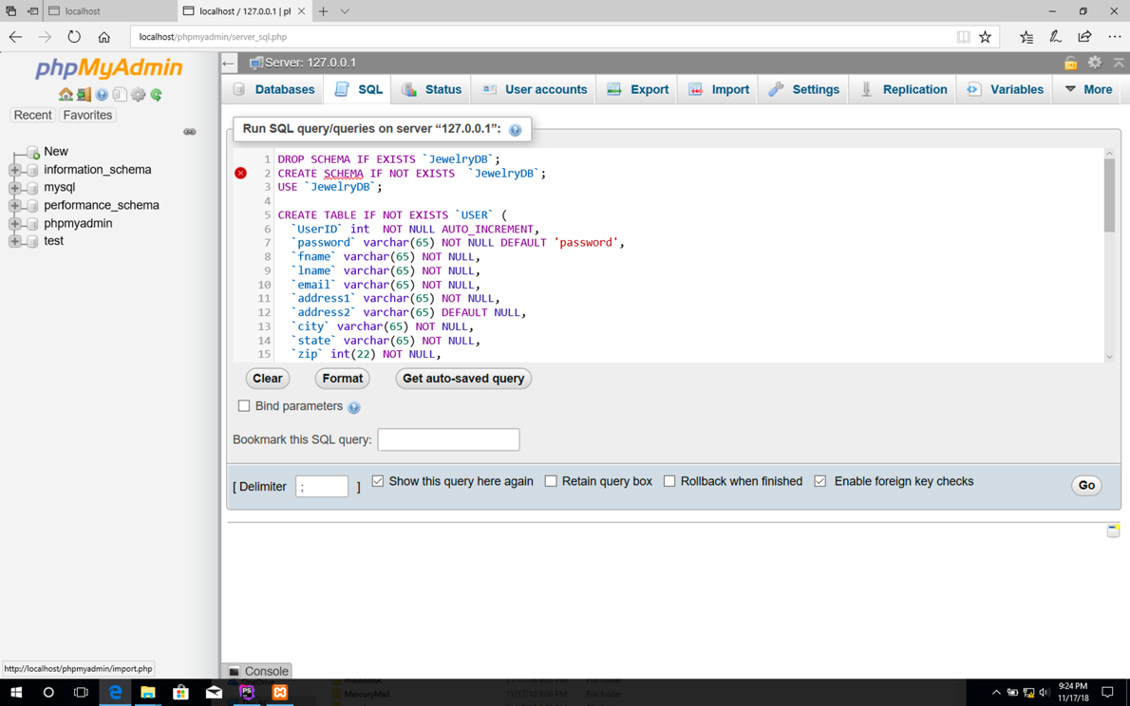
  + After you have database created you can click on JewelryDB from left side and update the database as needed.
* Our data base is not online, it is only local. PhpMyadmin is only local for now. if you make any changes, you will have to sent the sql script to everyone so we all have the same sql file.
* Install phpstorm
  + This is the software where we write HTML, CSS and PHP
  + We will use GitHub so it is easier for all of us to work on same code
  + I think we should all split web pages that we work on so we don’t work on same things.
  + Create jetbrains account using your UMICH email.
  + Fill this form out for free license
    - <https://www.jetbrains.com/shop/eform/students>
  + Download
    - <https://www.jetbrains.com/phpstorm/>
  + Open project from source control
    - Log in to GitHub
    - Then choose git from dropdown
      * I have put all of you as Collaborators so you should be able to choose this project from drop down.
      * If you don’t have GitHub account, could you create one.
    - If not Enter URL: <https://github.com/jkumar22/JewelryDBProject.git>
    - And local storage location to store project on your PC.
    - It should pull the project and open the project.
    - Please take look at each file and get familiar with it.
  + After project is open
    - File > settings > language and Frameworks > PHP
    - For CLi inspector, click on three dots.
    - Click Plus button > local path to inspector
    - Select a PHP executable: C:\xampp\php\php.exe
    - Apply > OK
  + Click view from menu bar > toolbar
  + Open pages folder > click > register.php file to open
  + Click play button to test the side
* After you make your changes make sure to commit and push your changes to GITHUB
  + Click on VCS in menu bar
    - Click commit
      * Add comment and then click dropdown on button commit
        + Click commit and push
  + This will save your changes to GITHUB where everyone can pull it.
  + To pull changes from GITHUB
    - Click update project from VCS > ok
* You can also manage the database from PhpStorm
  + On the right side click on database tab.
  + There should be connection to JewelryDB@localhost
  + Click on gear on top of database icon,
    - Enter user name “root”. See screen capture below
    - Click test connection. It should say success in green.
    - 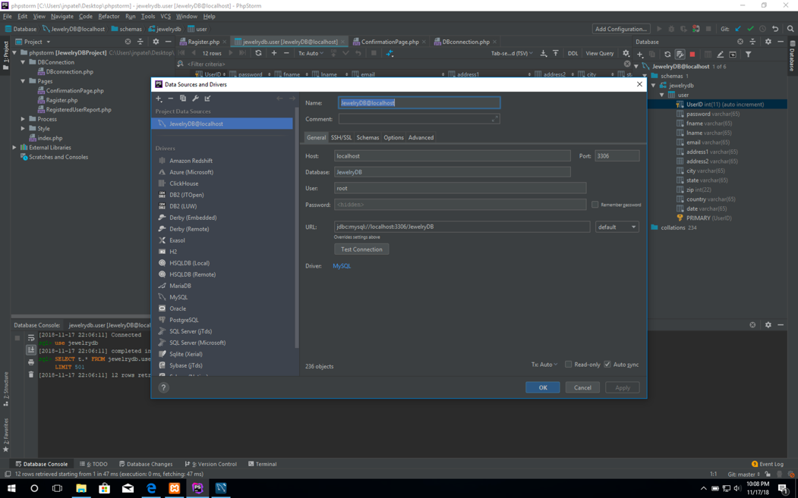
  + On right of red square there is edit data button
    - click on it to edit the database
  + After you have finished editing make sure to click on green arrow button to save the update.
  + Database on PhpMyadmin and here should be same.
  + 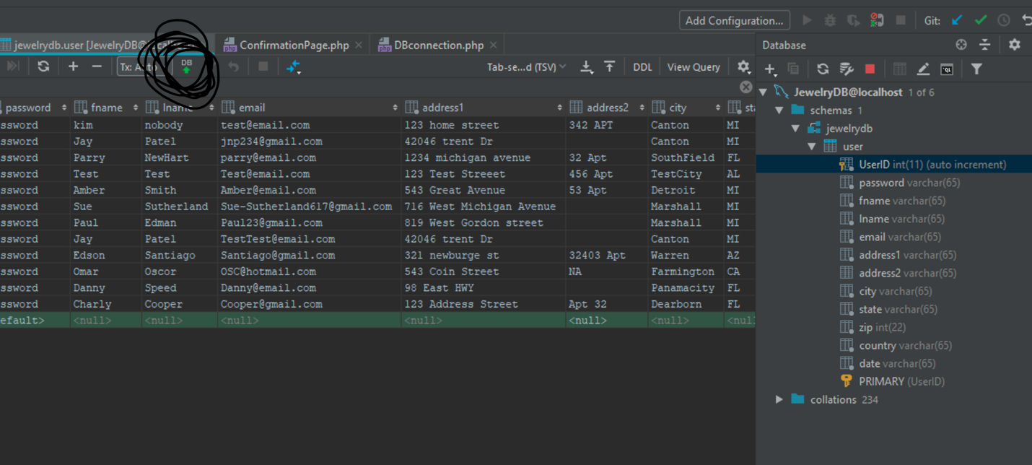
* Jewelry Project is on github
  + <https://github.com/jkumar22/JewelryDBProject>
* MySQL workbench. (Optional)
  + I was unable to use figure out how to use My SQL workbench as our databse server so PhpMyAdmin will have to be our database server for now.
  + If you like we can use this to practice writing the SQL script here and then pate it on the PhpMyadmin. Good way to learn.
  + I like workbench as it has good interface for writing SQL and testing it.
* 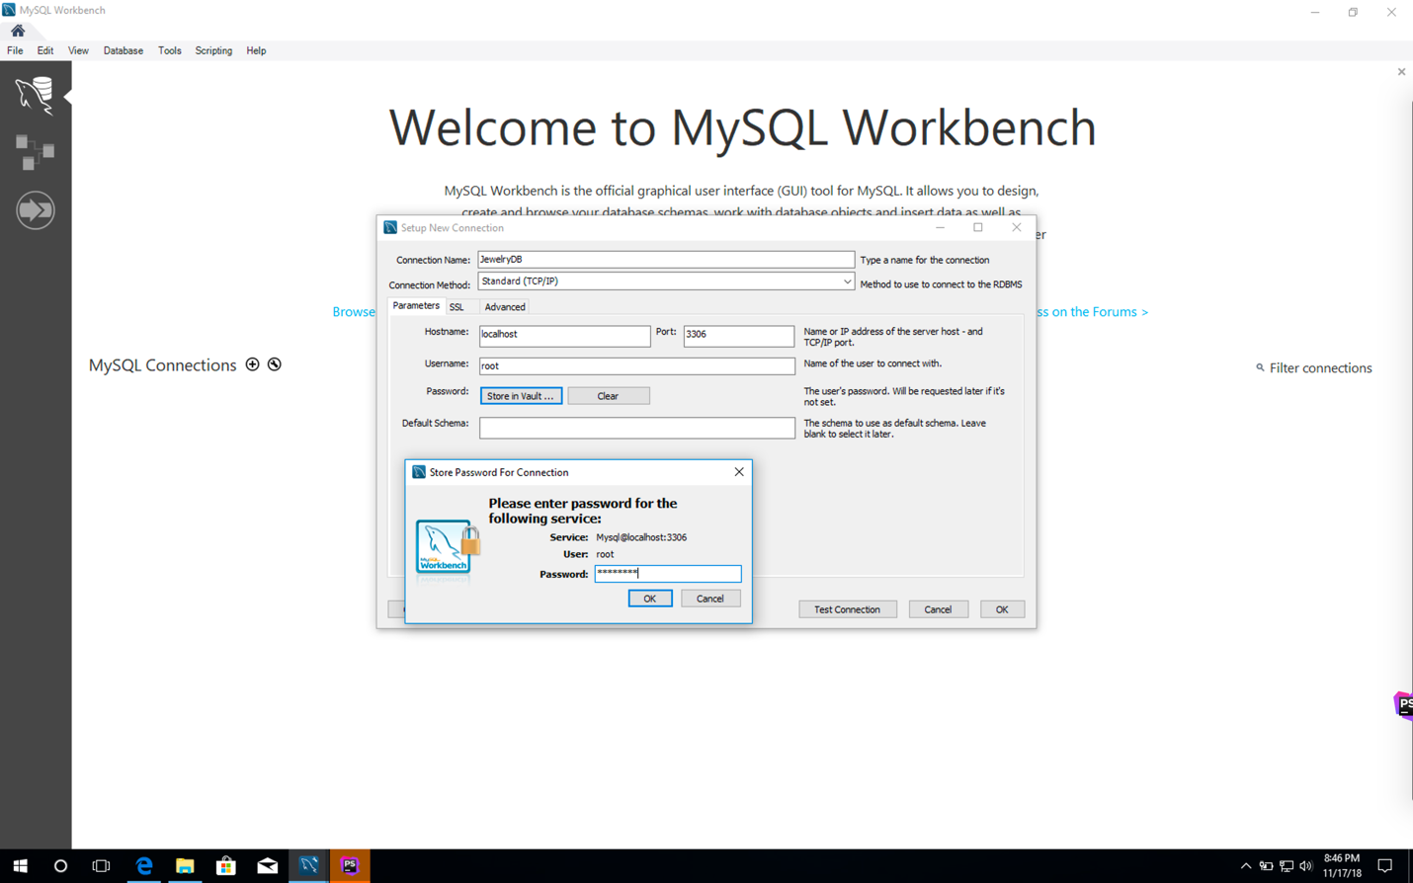
* Enter info as shown in screen capture
* Click store in vault and enter “password” as your password
* click test connection.
  + It should say connection successful
* Click
* Then click on the connection you just created.
* Now you are able to write SQL script here and create your data base.
* 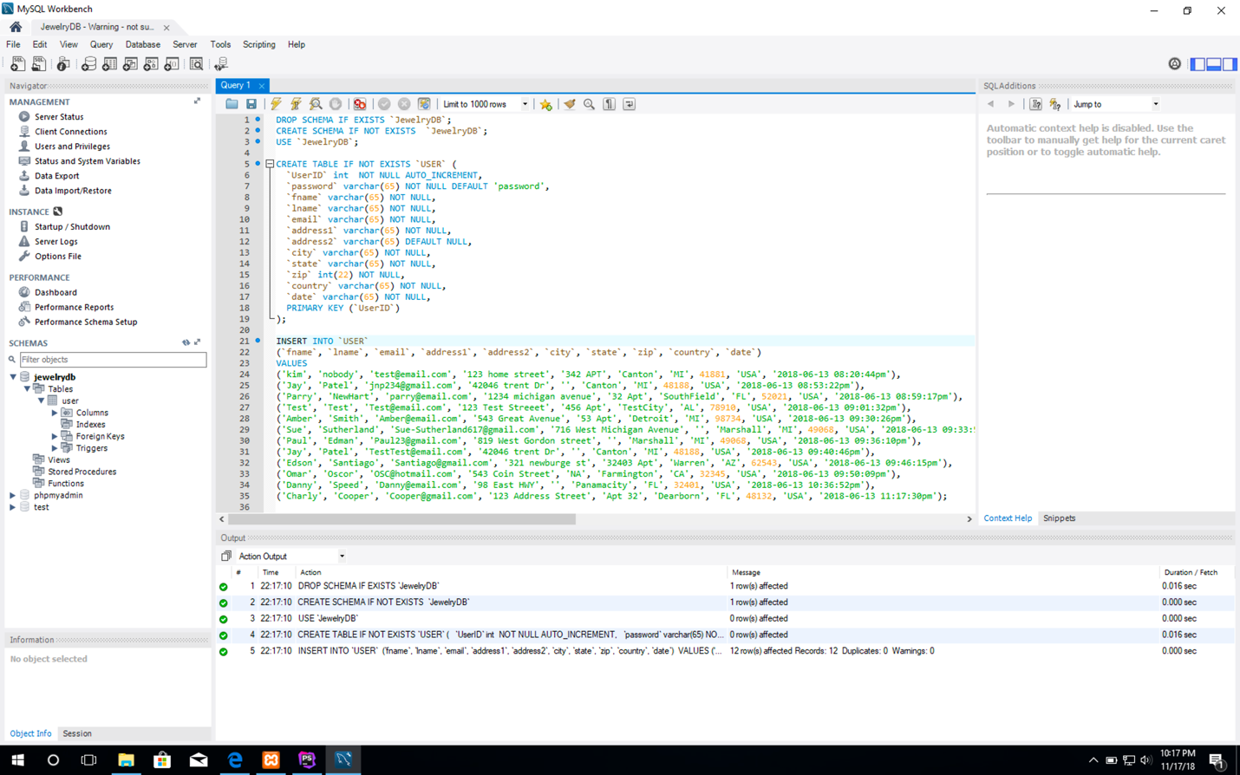
* After you write the SQL you click on the lightening icon to run the script.
* On the left under schema, click on the refresh button.
  + You should see your DB and tables there.
    - Click on the table to see what is in the table.